**03-REACTJS-HANDSON**

Create a react app for Student Management Portal named scorecalculatorapp and create a function component named “CalculateScore” which will accept Name, School, Total and goal in order to calculate the average score of a student and display the same.

1. Create a React project named “scorecalculatorapp” type the following command in terminal of Visual studio:



1. Create a new folder under Src folder with the name “Components”. Add a new file named “CalculateScore.js”
2. Type the following code in CalculateScore.js

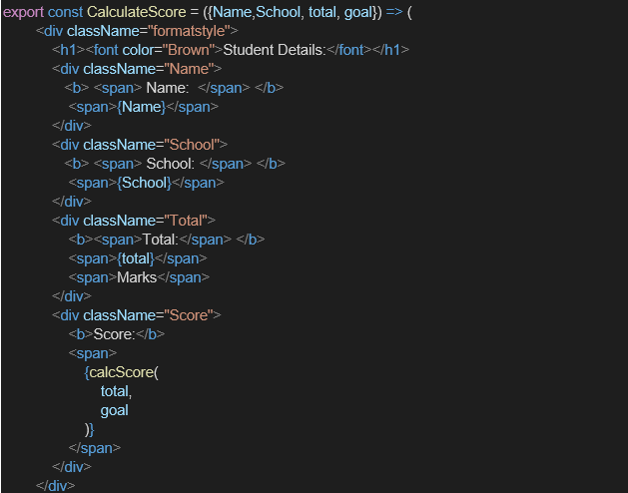

1. Create a Folder named Stylesheets and add a file named “mystyle.css” in order to add some styles to the components:

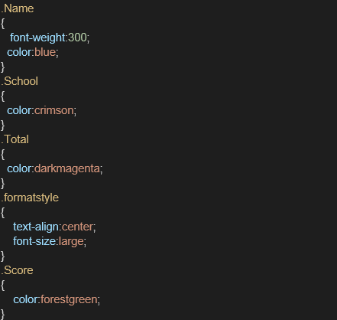

1. Edit the App.js to invoke the CalculateScore functional component as follows:



1. Edit the App.js to invoke the CalculateScore functional component as follows:

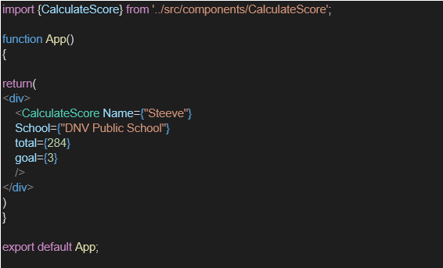

1. In command Prompt, navigate into scorecalculatorapp and execute the code by typing the following command:



1. Open browser and type “localhost:3000” in the address bar:

**Output:**

**CalculateScore.js**

**import** React **from** 'react';

**import** '../Stylesheets/mystyle.css';

**function** CalculateScore() {

**const** name **=** "Aathithiyaa";

**const** school **=** "Sunshine School";

**const** total **=** 480;

**const** goal **=** "To score above 90%";

**const** average **=** total **/** 5;

**return** (

    <div *className***=**"score-card">

      <h2>Student Score Card</h2>

      <p><strong>Name:</strong> {name}</p>

      <p><strong>School:</strong> {school}</p>

      <p><strong>Total Marks:</strong> {total}</p>

      <p><strong>Average Score:</strong> {average}</p>

      <p><strong>Goal:</strong> {goal}</p>

    </div>

  );

}

**export** **default** CalculateScore;

**mystylesheets**

.score-card {

  border: 2**px** solid #4caf50;

  padding: 20**px**;

  margin: 20**px**;

  background-color: #f0f9f0;

  border-radius: 10**px**;

  font-family: Arial, sans-serif;

}

.score-card h2 {

  color: #2e7d32;

}

.score-card p {

  font-size: 16**px**;

  margin: 5**px** 0;

}

**App.js**

**import** React **from** 'react';

**import** CalculateScore **from** './Components/CalculateScore';

**function** App() {

**return** (

    <div *className***=**"App">

      <CalculateScore />

    </div>

  );

}

**export** **default** App;

**Output:**

